# CS 255 Business Requirements Document Template

## System Components and Design

### Purpose

*What is the purpose of this project? Who is the client and what do they want their system to be able to do?*

* Client is DriverPass owner Liam and his IT Officer Sam
* Client wants to fill market gap by providing better training for driving students taking tests at the DMV via online classes, practice tests, and on-the-road training
* Client wants customers to have ability to book these packages based on their driving needs

### System Background

*What does DriverPass want the system to do? What is the problem they want to fix? What are the different components needed for this system?*

* Accessible data both online and offline on any kind of mobile device or desktop
* System should be cloud based
* System should offer employees downloadable reports and metrics
* Notify necessary employees of any changes to records
* Keep detailed, printable logs of specifics surrounding aforementioned changes (who, when, why)
* Grant ability to disable packages
* Needs components for a reservation system, DMV update notification system, online lessons/tests, account creation, and a component for customers to contact the company and the company to contact customers

### Objectives and Goals

*What should this system be able to do when it is completed? What measurable tasks need to be included in the system design to achieve this?*

* Customers can decide day and time to take lessons and can book via online account, phone call, or schedule in person
* Customers will have the ability to create, modify, and cancel appointments online
* Customer can choose pickup and drop off location
* Client should be able to track what user is matched with what driver, what time, and what vehicle is used
* Client should have visibility to customer registration information and details
* Measurable tasks need to include avoidance of data redundancy to achieve standard online/offline access

## Requirements

### Nonfunctional Requirements

*In this section, you will detail the different nonfunctional requirements for the DriverPass system. You will need to think about the different things that the system needs to function properly.*

#### Performance Requirements

*What environments (web-based, application, etc.) does this system need to run in? How fast should the system run? How often should the system be updated?*

* The system should be web based, making it easier for users to access without downloading an app.
* The system should be cloud based with ability to run offline
* The system should be regularly updated by the IT team for any bugs that are reported.
* The system should also be regularly updated once the DMV changes requirements.

#### Platform Constraints

*What platforms (Windows, Unix, etc.) should the system run on? Does the back end require any tools, such as a database, to support this application?*

* The system should be compatible with all platforms. It defeats the purpose of accessibility if not.
* The backend requires a database that holds saved user info, saved driver info, and course progress. Data cannot be updated unless user is online.

#### Accuracy and Precision

*How will you distinguish between different users?* *Is the input case-sensitive? When should the system inform the admin of a problem?*

* Different users will be distinguished by unique tokens assigned to each user, creating a user id.
* Input for passwords is case sensitive.
* The system should inform admins of a problem when it is likely that a modification will cause a problem, as well as when there is an active issue due to a change or missing information.

#### Adaptability

*Can you make changes to the user (add/remove/modify) without changing code? How will the system adapt to platform updates? What type of access does the IT admin need?*

* The system should have a maintenance schedule set by the IT team outside of peak business hours.
* Major updates such as new features will be deployed as necessary.
* The IT admin needs access over the entire system, with checks and balances of course. Each action by the admin (and any user) should be logged in an audit trail.
* Making changes to the user should not require changes to code. The code should be reusable, therefore user attributes should be stored in editable variables, not hard coded.

#### Security

*What is required for the user to log in? How can you secure the connection or the data exchange between the client and the server? What should happen to the account if there is a “brute force” hacking attempt? What happens if the user forgets their password?*

* Log in requires username and password.
* If a user forgets password, they can click a password reset button that generates a code for them to update password. Advanced issues should go through a contact form for the IT department.
* The connection needs to be secured via digital certificates with SSL and TLS
* If there is a brute force hacking attempt, the account should be locked and able to be unlocked by contacting the IT department to verify account ownership.

### Functional Requirements

*Using the information from the scenario, think about the different functions the system needs to provide. Each of your bullets should start with “The system shall . . .” For example, one functional requirement might be, “The system shall validate user credentials when logging in.”*

* The system shall validate user credentials when logging in
* The system shall give user specific capabilities based off of their account status and credentials.
* The system shall allow customers to take online classes and practice tests and view their progress and completion.
* The system shall be cloud based, accessible offline and online across all platforms.
* The system shall include an audit trail for all changes.
* The system shall make visible driver, car and customer pairing.
* The system shall allow package disabling.
* The system shall allow customer registration, payment, and booking.
* The system shall notify admins of DMV changes.
* The system shall allow students to contact organization and organization to contact student.

### User Interface

*What are the needs of the interface? Who are the different users for this interface? What will each user need to be able to do through the interface? How will the user interact with the interface (mobile, browser, etc.)?*

* Users of the interface include students, DriverPass instructors, DriverPass IT employees, DriverPass secretaries, and DriverPass administrators
* Secretaries need ability to add student information and payment method
* Students need to be able to access learning content and view their status and driver notes. They also need to be able to update their personal information, book and modify appointments.
* Instructors need ability to create course content, upload/download files and notes, view reports on grades, and view student progress
* DriverPass Administrators need the capability to upload and download files, view only on course content and user responses, and the ability to download analytic reports of site activity and record changes.
* IT Employees need the ability to track system changes, change passwords, and change emails. They also need ability to view/edit student information, and block access to users if need be.
* All users should be able to contact one another, from students to company and vice versa
* All users should be able to interact with the interface on any platform, whether it is mobile, desktop, or tablet.
* Interface should show online test progress, driver and student photos, special needs, and user info.

### Assumptions

*What things were not specifically addressed in your design above? What assumptions are you making in your design about the users or the technology they have?*

* One assumption would be that backend servers are reliable and have steady connections and regular support
* Another assumption would be that DriverPass has a very large budget, as they have not specified a monetary cap in the documentation.
* We assume that DriverPass has a healthy amount of employees within the company.
* An assumption is that every user is able bodied. The system does not account for deaf students, for example, and the need for closed captions on learning videos.

### Limitations

*Any system you build will naturally have limitations. What limitations do you see in your system design? What limitations do you have as far as resources, time, budget, or technology?*

* Platform must be cloud based.
* The platform will not work if connection to servers is lost due to insecure connection.
* There are only three employees of DriverPass mentioned - Liam being the Owner, Ian being the IT officer, and an unnamed secretary. We are unsure if DriverPass has more employees to help build and maintain the system. That leaves us with a gap in people resources.

### Gantt Chart

*Please include a screenshot of the GANTT chart that you created with Lucidchart. Be sure to check that it meets the plan described by the characters in the interview.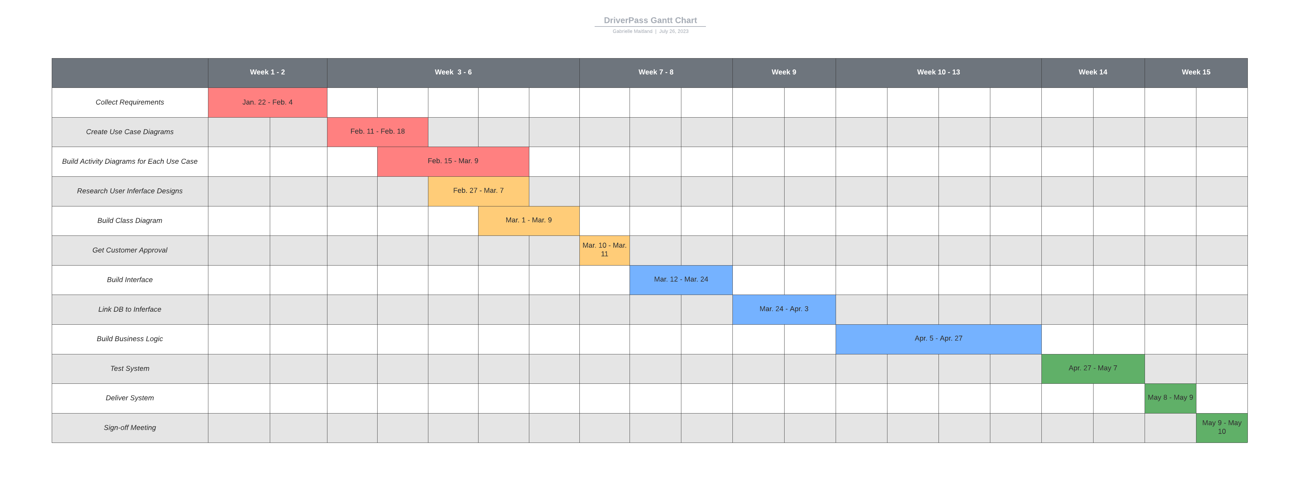*

*References:*

*IBM documentation*. (n.d.). <https://www.ibm.com/docs/en/spectrum-protect/8.1.3?topic=server-securing-communications>

Log, B. (2021). Top 10 Weightiest LMS Functional Requirements. *HuskyJam*. <https://huskyjam.com/blog/lms-functional-requirements/>

Southern New Hampshire University. (n.d.). *CS 255 DriverPass Interview Transcript*. snhu.edu.